REST Api FOR CRUDE ACTION

POST REQUEST

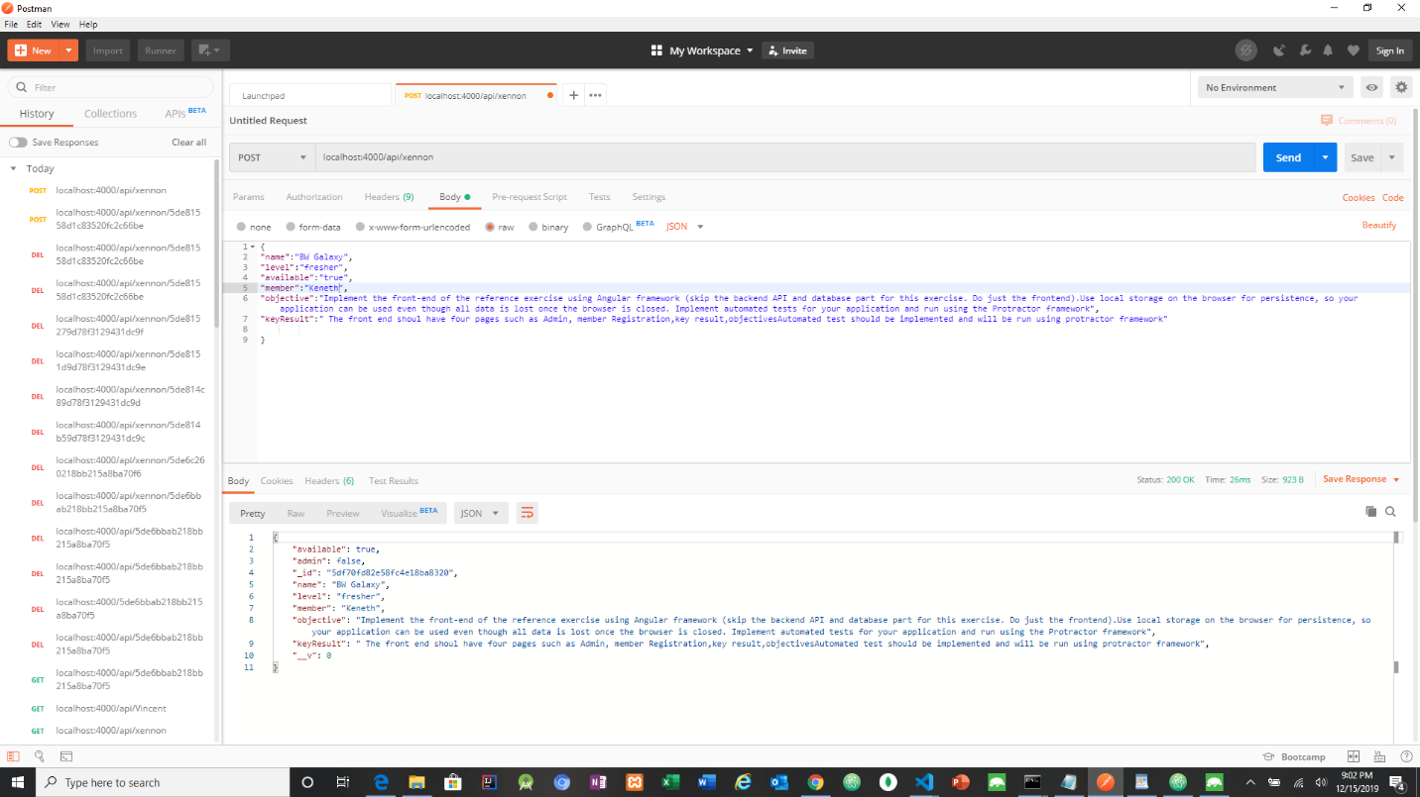

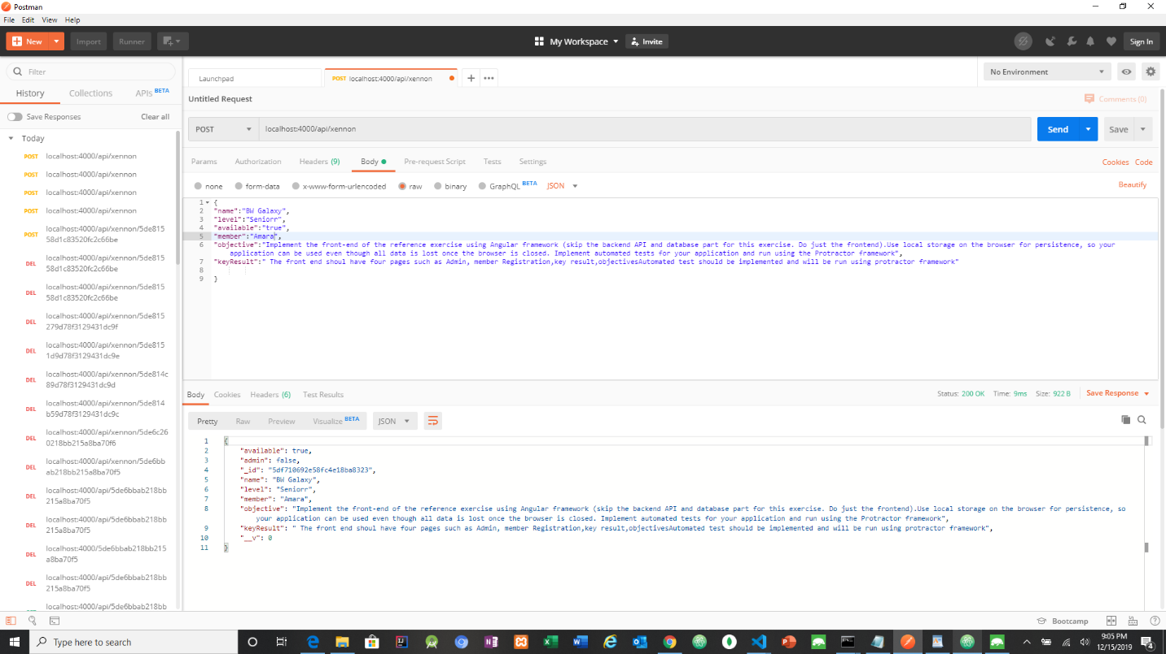

GET REQUEST

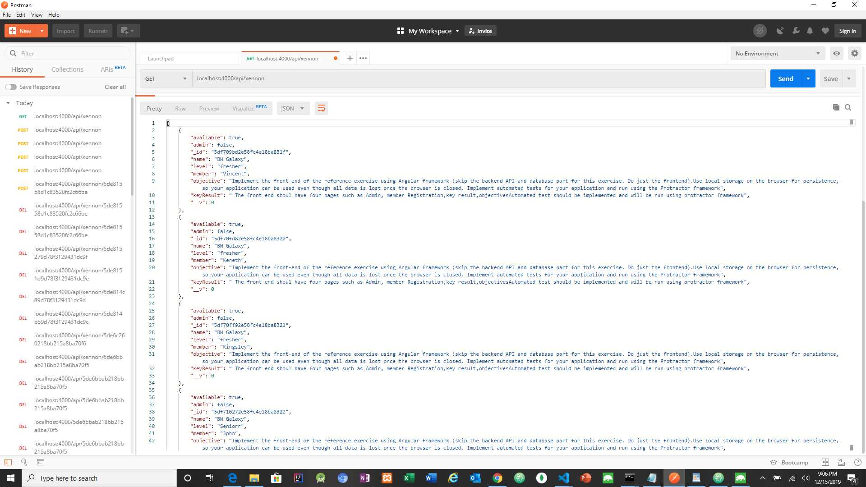

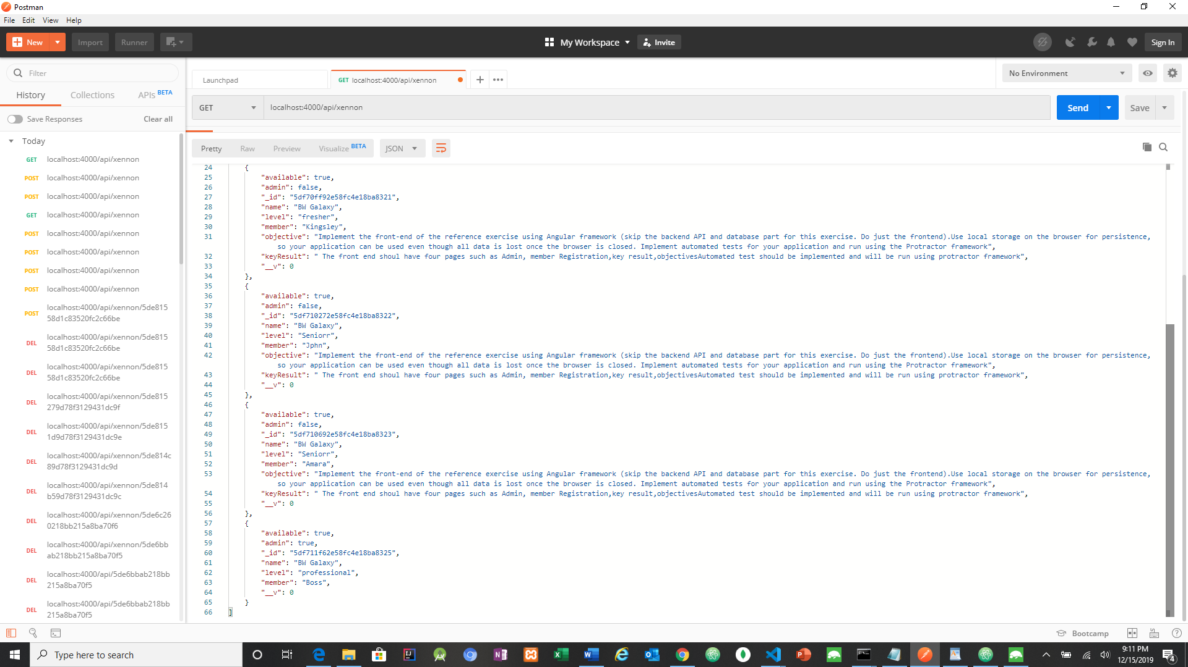

PUT REQUEST

MEMBER BECOME ADMIN AFTER A PUT REQUEST

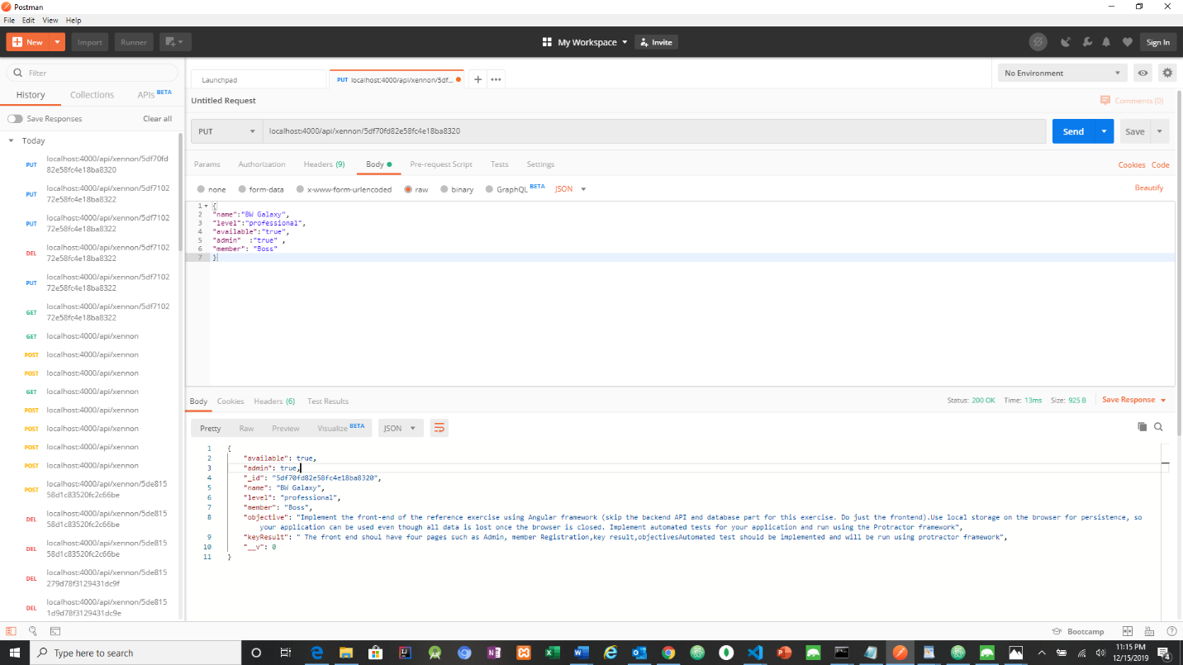

DELETE REQUEST

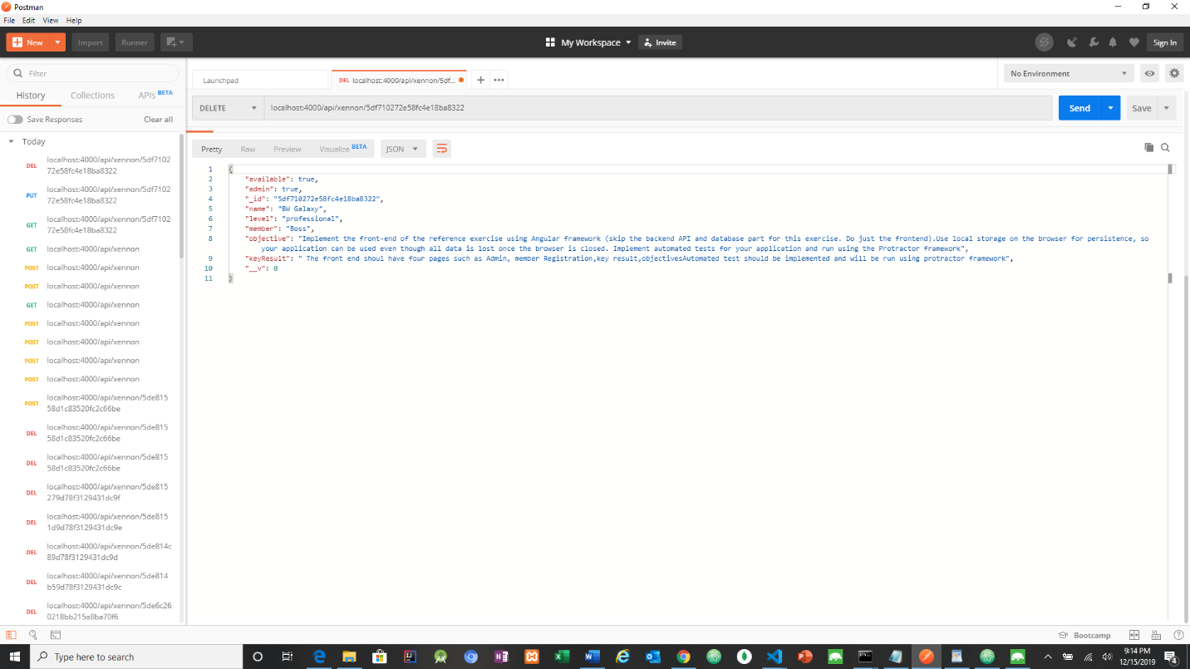

ROBO MONGO DATABASE RESPONSE

BEFORE DELETE REQUEST IS DONE

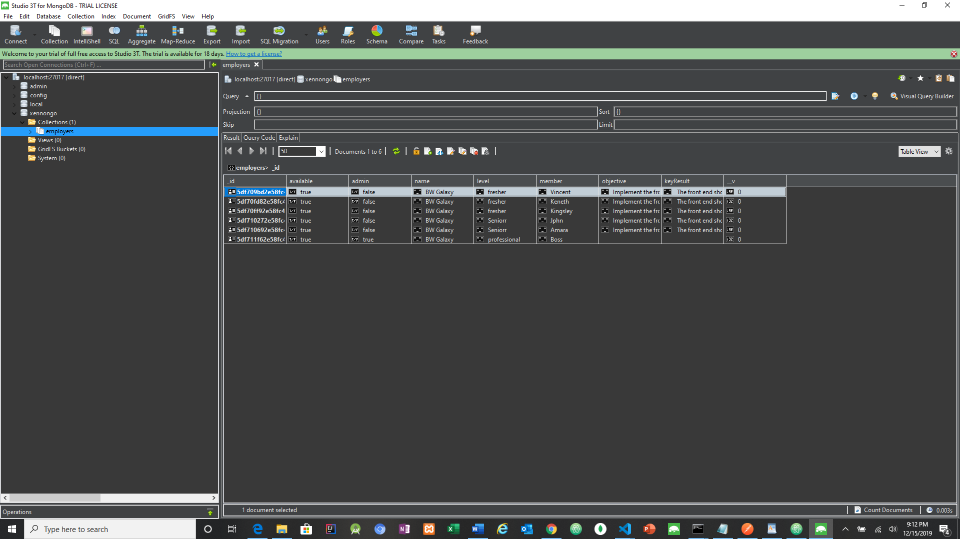

AFTER DELETE REQUEST IS DONE

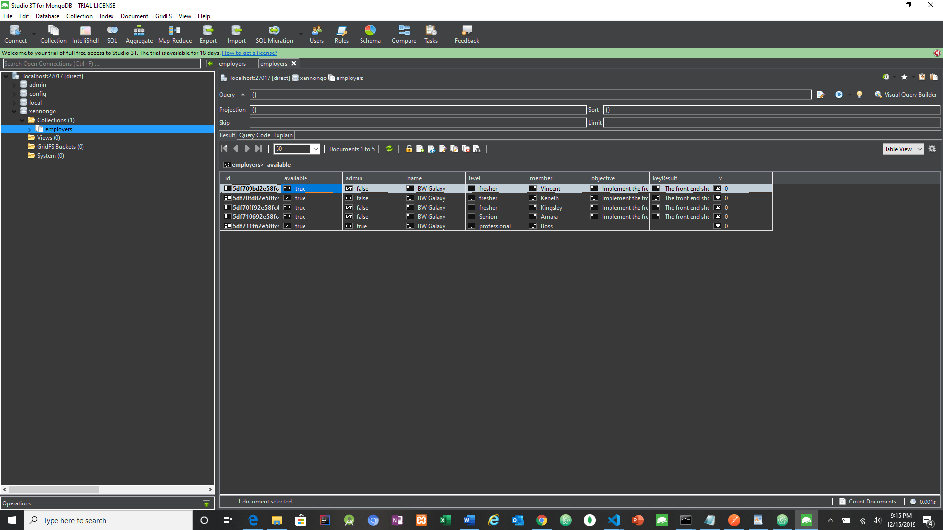

DATABASE AFTER PUT REQUEST

